What are the problems I want to solve?

How do I test the animation sequence that I designed for movement works?



How Will/did I solve this?

I will use the DOT method of Workshop-prototyping.

I started by making a paper prototype of the characters

I combine the flipbook animation method with stop motion capture by drawing a few sequences of movement of our player on paper and used an app (“Stop Motion Video Maker”) that we found for free on the play store for stop motion capture to make it into a 2D animation sequence.

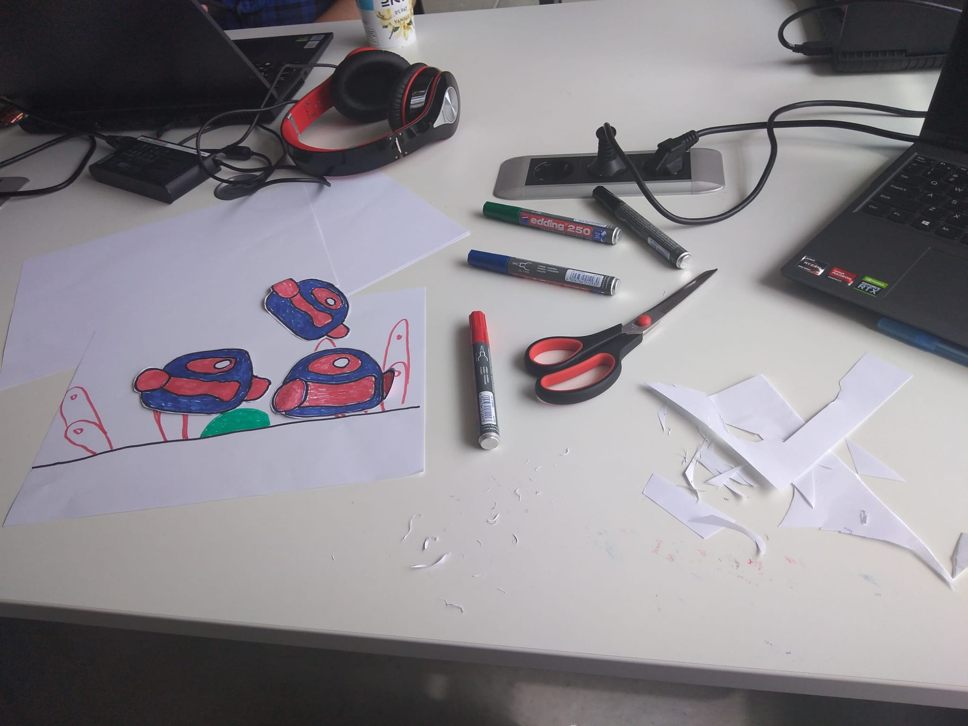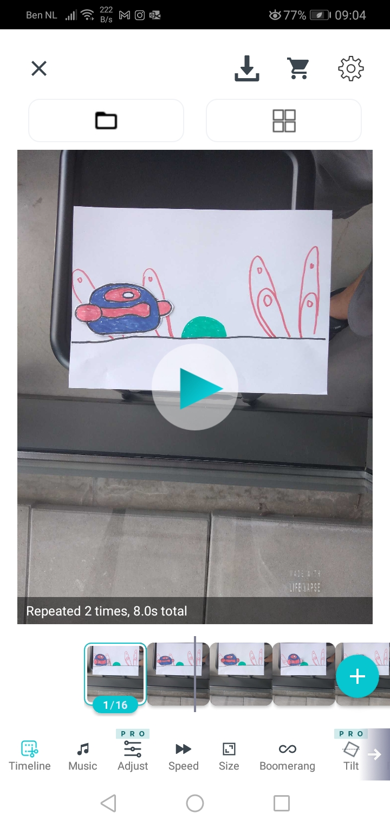

What are the results?



What is the quality of the results?

Results where good

What is the next step now that I have these results?

The next step is figuring out how to make 2D animation in unity.